DATA FLOW DIAGRAM OF EDUANALYTICS SYSTEM - (DFD LEVEL - 0)
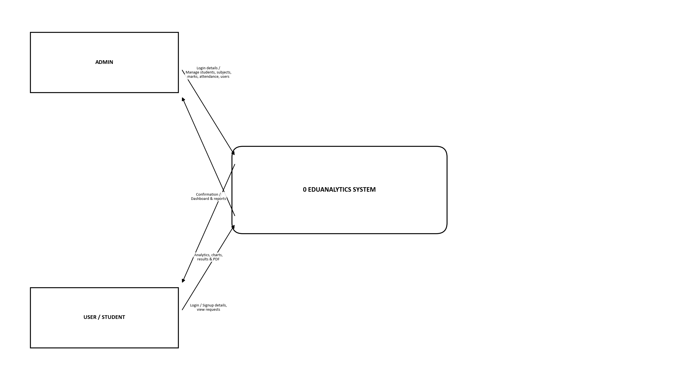
DATA FLOW DIAGRAM OF EDUANALYTICS SYSTEM - (DFD LEVEL - 1)
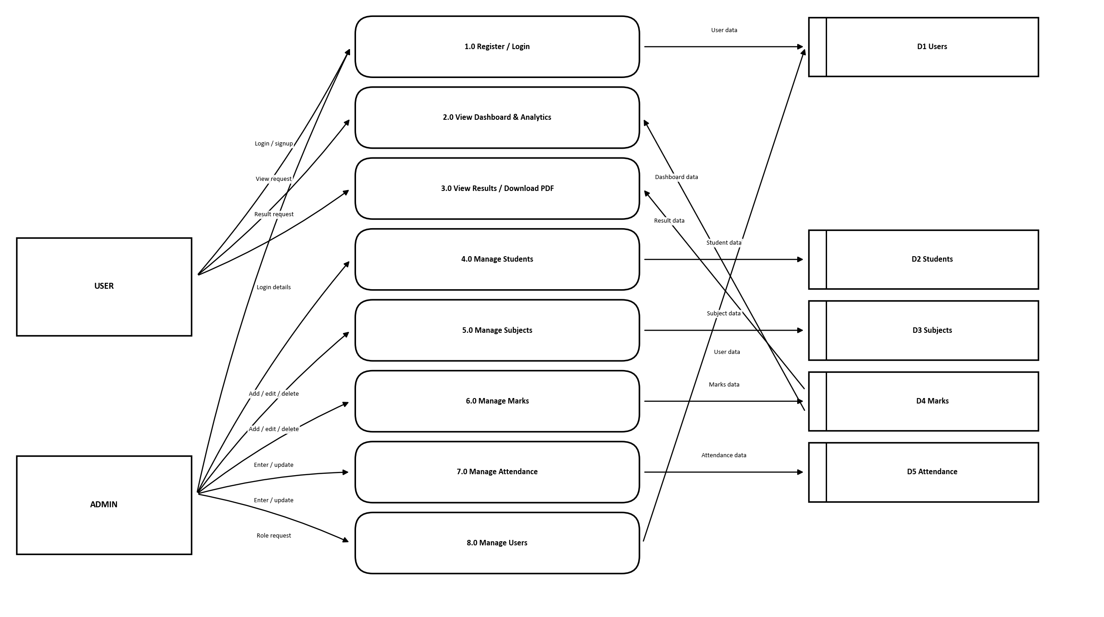
DATA FLOW DIAGRAM OF EDUANALYTICS SYSTEM - (DFD LEVEL - 2)
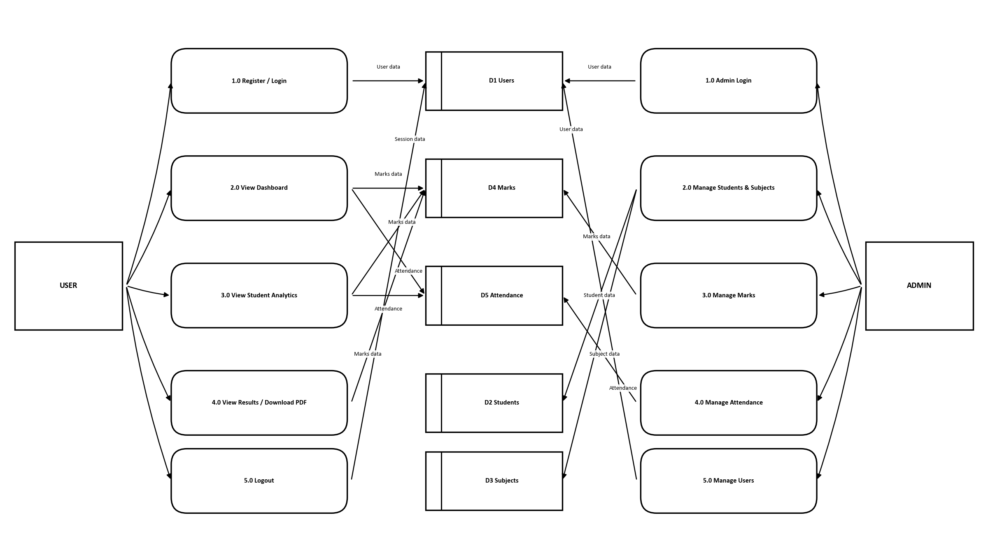
DATA STORES (DATABASE TABLES)
D1 - Users (Stores user login accounts and roles) | D4 - Marks (Stores internal 1, internal 2 and assignment marks)
D2 - Students (Stores student profile and roll no details) | D5 - Attendance (Stores total / present classes per subject)
D3 - Subjects (Stores subject code and name)

DATA FLOW NOTATION USED
External Entity | User / Admin - source or destination of data
Process | Function of the system that transforms data (1.0, 2.0, ...)
Data Store | Database table that stores data (D1, D2, ...)
Data Flow | Direction in which data moves between components

